List:
- A list data structure on Python that is a mutable, or changeable, ordered sequences of elements.
- Each element or value that is inside of a list is called an item.
- Just as strings are defined as characters between quotes, lists are defined by having values between square brackets [ ] and every value is separated by, (comma).
Friends = [‘Hamza’,’Fatima’,’Azhar’,’laiba’,’Ali’,’Zoya’]
Numbers = [1,2,3,4,5,6,7,8,9]
List_float = [2.43,98.68,7.45,45.65]
Mix = [‘Ahsan’,2,4.56,6.87,True,’Maham’,56,False]

Common List Operations:
- Access value
- Add new value at the end / tail of list
- Find the index of a value in list
- Slicing the element from list
- Deleting & removing the elements from list
- Popping elements from the list
Creating the List & Checking length of list:

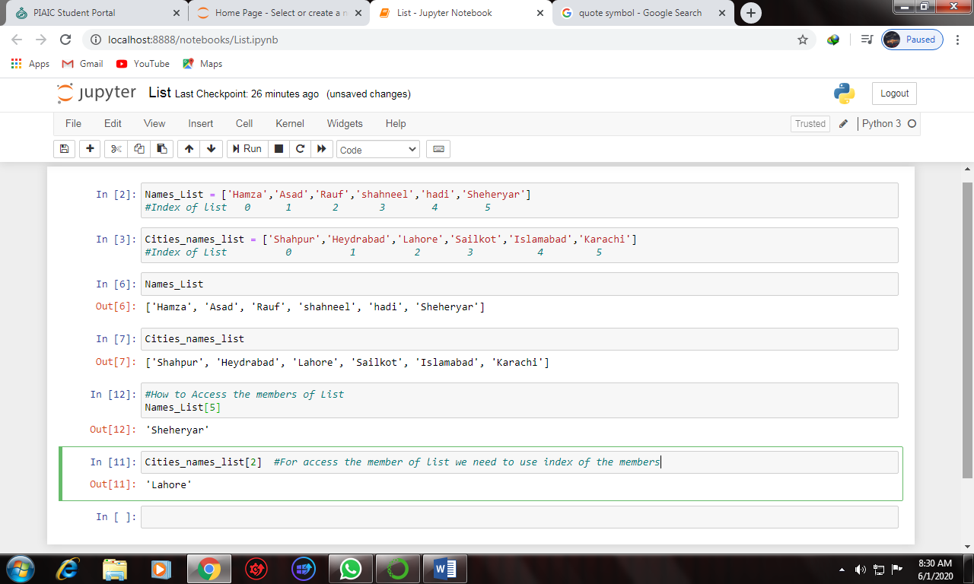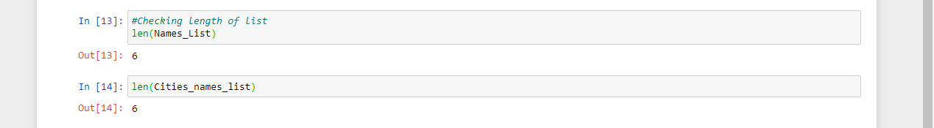
Accessing the value:

Adding a member in list [ Append, Insert]

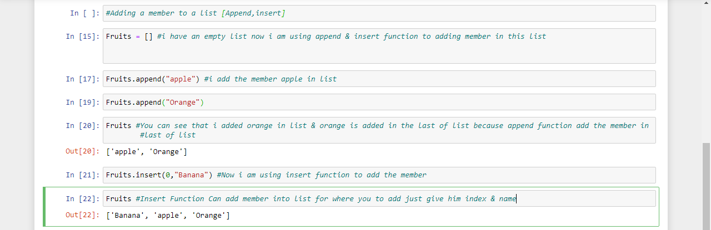
Extend & Count Function:

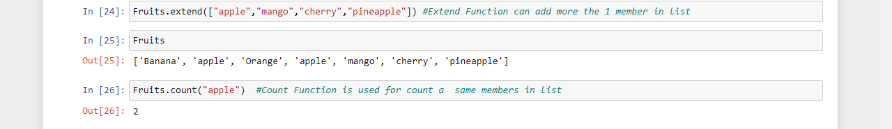
Copy & Index Function:

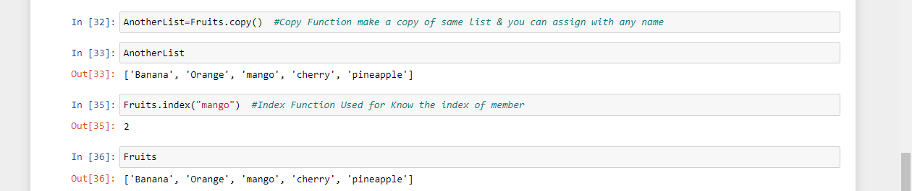
Removing an Item From list:

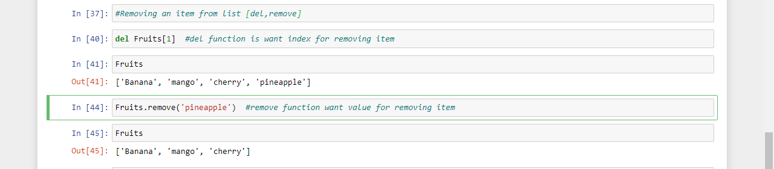
Pop Function:

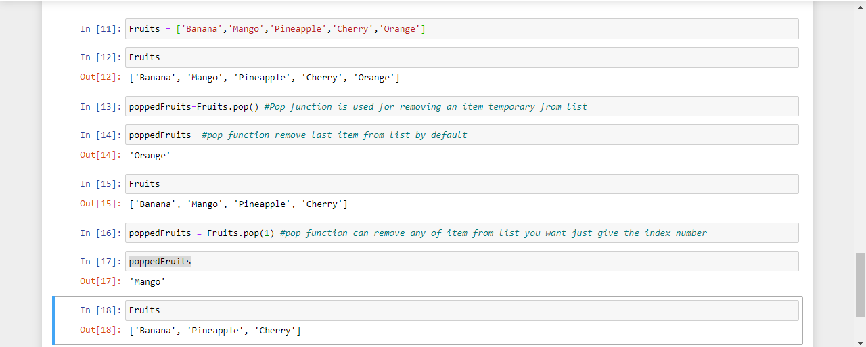
Sort Function:

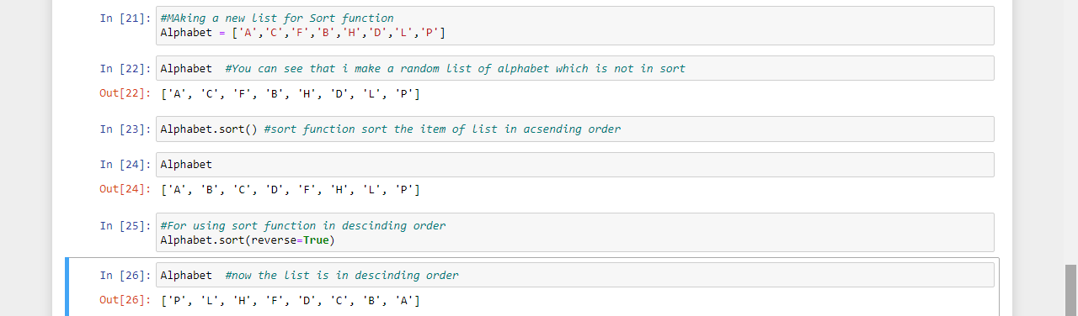
Reverse & Clear Function: 